# 3D Printing Report – August 26th 2023

|  |  |  |  |
| --- | --- | --- | --- |
|  | Pen and Paper | Paper and Form | Full Form |
| Average Turnaround Time | idk | 13.6 Days | 4.5 Days |
| Flagged emails (%) | Many | 0% | 2% |
| Failed prints (%) | Many | 16% | 10% |
| Percent picked up | Who Knows | 58% | 69% |
| Percent of 1 off prints | Basically all | 69% | 54.2% |

**Average Turnaround Time:** Time it takes fromwhen we received the print to when we contact the patron that it’s completed.We want this time to be as low as possible.

**Flagged emails (%):** Percentage of patron’s emails that did not work when trying to contact them (the email address bounced). We want this percentage to be low so that the email script will properly contact patrons informing them that their print is ready for pickup.

**Failed prints (%):** Percentage of prints that we could not complete (For reasons such as complexity, does not fit our equipment, or many files in a request). We want this to be low because failed print means more work for us in contacting the patron to find a viable one.

**Percent picked up:** The percentage of people who picked up their completed print request**.** We want this percentage to be as high as possible**.** This will be influenced by our turnaround time and consistently using the email script to contact patrons.

**Percent of 1 off prints:** The percentage of patrons who requested a print that was not previously tested by us and known to work on our printers**.** We want this to be a healthy number because while it may be more difficult for staff to print and test a lot of 1 off prints, one of the goals of our 3D printing program is to introduce patrons to repositories like thingiverse that highlights all the cool and useful problems you can solve with 3D printing!

Top Prints **since** we launched the online form:  
32 other prints that were unique and only printed once

|  |  |
| --- | --- |
| **Print** | **Count** |
| Articulated Octopus | 8 |
| Articulated Dragon | 6 |
| Millennium Falcon | 4 |
| Articulated Snake | 3 |
| Dog | 2 |
| Kirby | 2 |
| MSU Logo | 2 |

Top Prints **before** we launched the online form:

56 other prints that were unique and only printed once

|  |  |
| --- | --- |
| **Print** | **Count** |
| Flexi-Unicorn | 5 |
| Charmander | 3 |
| Dog | 3 |
| Articulated snake | 2 |
| Caticorn | 2 |
| Kirby-easy to print | 2 |
| Low Poly Fox | 2 |
| Low Poly Teddy Bear | 2 |
| Octopus | 2 |
| Pikachu | 2 |

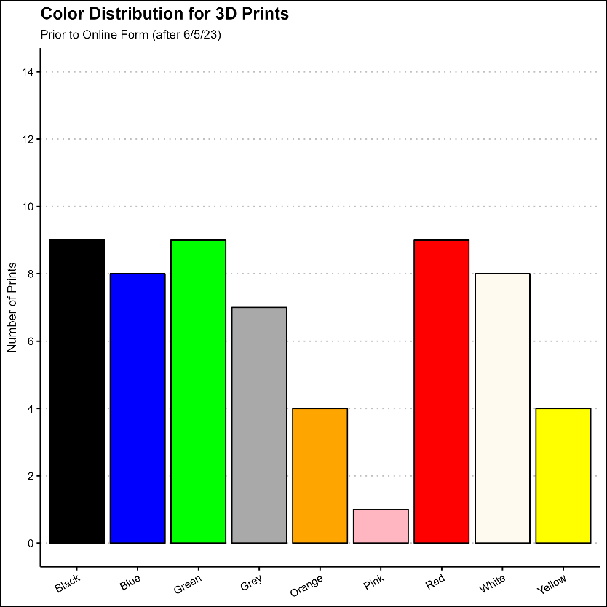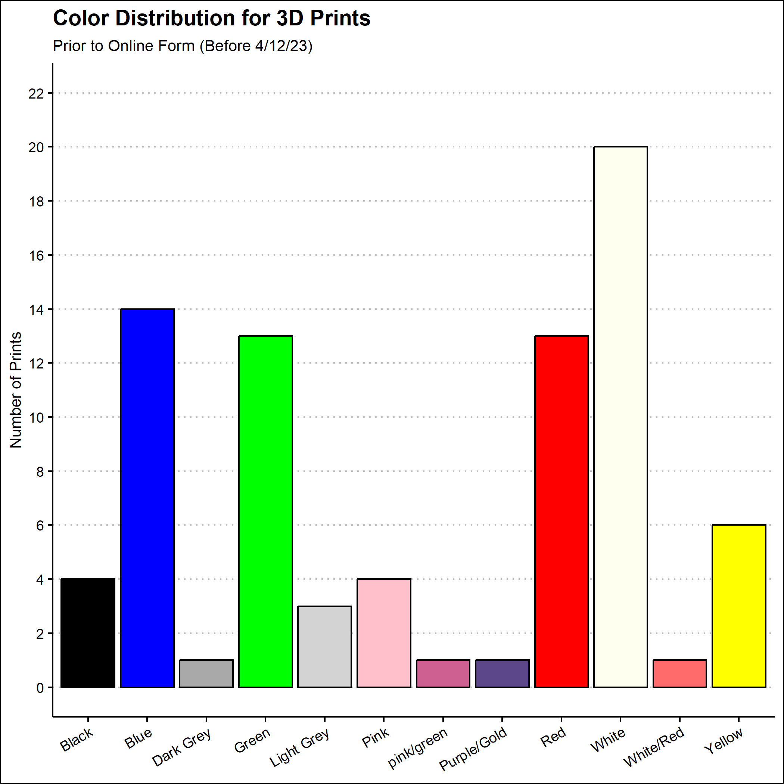

*Note: IT has not updated the colors on our form in quite some time, so that’s why not all of our newer colors are getting used